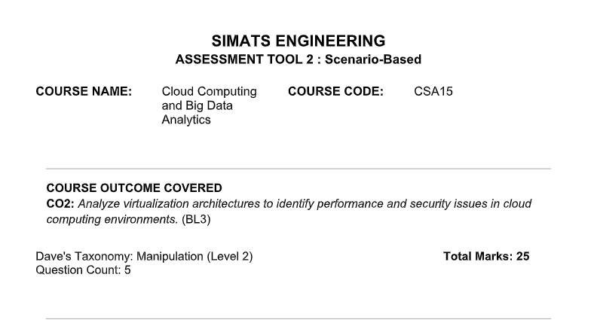

Code of Conduct
I __Harsita Ashok (192521086)__ (Name / Reg No) certify that this submission is my original work and that I have adhered to the guidelines specified for this assessment. I understand that any violation of academic integrity rules will result in disciplinary action.

Signature of the student: __ Harsita Ashok ___

Assessment Tasks
Scenario-Based Questions

1. A media company wants to migrate its video streaming platform to the cloud.
The system must handle millions of concurrent users with minimal buffering.
Design a cloud architecture using scalability and caching techniques.
Explain how load balancing and auto-scaling can ensure smooth streaming.
Discuss cost optimization strategies for such high-demand workloads.

Answer:
A media company can migrate its video streaming platform to the cloud by using a scalable cloud architecture consisting of a Content Delivery Network (CDN), load balancer, auto-scaling application servers, cloud storage, video processing services, and databases.
Users
↓
DNS Service
↓
Content Delivery Network (CDN)
↓
Load Balancer
↓
Auto-Scaling Application Servers
↓
Streaming Services / Video Processing
↓
Cloud Storage + Database
Videos can be stored in cloud object storage and delivered through a CDN, which caches popular video content at servers located closer to users. This reduces network delay, improves video loading speed, and minimizes buffering. Adaptive bitrate streaming can also be used to automatically adjust video quality based on the user’s internet speed. A load balancer distributes incoming user requests across multiple streaming servers, preventing any single server from becoming overloaded. It also redirects traffic to healthy servers if a server fails, ensuring high availability and uninterrupted streaming. Auto-scaling automatically adds more servers during peak periods, such as during the release of a popular movie, and removes unnecessary servers when traffic decreases. This ensures smooth streaming performance while avoiding resource wastage. Cost can be optimized by using pay-as-you-go pricing, CDN caching, reserved cloud resources for predictable workloads, low-cost storage for old or rarely viewed videos, and serverless services for tasks such as video processing and notifications. Continuous monitoring can also help identify unused resources and reduce unnecessary expenses. Thus, the combination of caching, load balancing, auto-scaling, and cost-efficient cloud services enables the platform to support millions of concurrent users with minimal buffering and high performance.

2. A fintech startup is deploying applications using containers across multiple cloud providers.
They face challenges in maintaining consistency and managing deployments.
Propose a solution using container orchestration and multi-cloud strategies.
Explain how service discovery and scaling can be handled efficiently.
Highlight the benefits and risks of a multi-cloud deployment model.

Answer:
A fintech startup can manage containerized applications across multiple cloud providers by using a container orchestration platform such as Kubernetes. Kubernetes provides a consistent environment for deploying, managing, and monitoring containers, regardless of the cloud provider. The application can be divided into microservices, packaged into containers using Docker, and deployed on Kubernetes clusters in different cloud platforms. Infrastructure-as-Code tools can be used to maintain the same configuration across all cloud environments, while a centralized monitoring and management system can track application performance and resource usage. Service discovery can be handled using Kubernetes Services and DNS, which automatically identify and connect containers without requiring fixed IP addresses. When a container fails or is replaced, the service discovery mechanism automatically updates the connection details. Scaling can be managed using Kubernetes Horizontal Pod Autoscaler, which automatically increases or decreases the number of container instances based on CPU usage, memory usage, or user traffic. A multi-cloud deployment provides benefits such as high availability, improved disaster recovery, reduced dependence on a single cloud provider, better geographic coverage, and the ability to select the most suitable services from different providers. However, it also introduces risks such as increased management complexity, security and compliance challenges, higher data transfer costs, difficulties in maintaining consistent configurations, and possible network latency between cloud platforms. Therefore, the startup should use standardized container configurations, centralized security policies, automated deployment pipelines, and continuous monitoring to ensure reliable, secure, and efficient multi-cloud application deployment.

3. An e-learning platform experiences data loss due to accidental deletion in the cloud.
The organization needs a robust backup and disaster recovery strategy.
Design a solution using cloud-native backup, replication, and versioning. Explain how recovery time objective (RTO) and recovery point objective (RPO) are achieved.
Provide steps to ensure business continuity during failures.

Answer:
An e-learning platform can prevent data loss caused by accidental deletion by implementing a cloud-native backup and disaster recovery strategy using automated backups, data replication, and versioning. All important data, including student records, course materials, videos, assignments, examination data, and user information, should be stored in reliable cloud storage. Automated backups should be scheduled regularly, such as daily incremental backups and weekly full backups, to ensure that recent data can be recovered. Data should also be replicated across multiple availability zones or geographic regions so that a copy remains available even if one data center or cloud region fails. Object versioning should be enabled to maintain multiple versions of files and data. If a file is accidentally deleted or modified, the organization can restore an earlier version without losing the original information. Backup copies should be stored separately from the main application environment and protected using encryption, access control, and multi-factor authentication. A disaster recovery environment can be maintained in another cloud region, where application servers, databases, and storage can be restored quickly during a major failure. The organization should define recovery objectives, such as Recovery Point Objective (RPO), which specifies the maximum acceptable amount of data loss, and Recovery Time Objective (RTO), which specifies the maximum acceptable recovery time. Regular backup testing and disaster recovery drills should also be performed to verify that data can be restored successfully. Thus, cloud-native backup, replication, versioning, and disaster recovery mechanisms provide high data availability, fast recovery, and protection against accidental deletion and system failures.
Recovery Time Objective (RTO) is the maximum time allowed to restore the system after a failure. It can be achieved using a disaster recovery site, automated recovery, backup servers, and failover mechanisms. For example, if the RTO is 2 hours, the e-learning platform must be restored within 2 hours.
Recovery Point Objective (RPO) is the maximum amount of data loss allowed, measured in time. It can be achieved through frequent backups, continuous data replication, and cloud versioning. For example, an RPO of 15 minutes means that a maximum of 15 minutes of data may be lost.
To ensure business continuity, the organization should maintain regular backups, replicate data across different cloud regions, use automatic failover, monitor system health, and regularly test disaster recovery plans. These measures reduce downtime, prevent major data loss, and keep the e-learning platform available during failures.

4. A government agency is adopting a hybrid cloud model for sensitive and non-sensitive data.
Some applications must remain on-premises due to compliance requirements.
Design a hybrid architecture that ensures secure communication between environments.
Explain how identity management and encryption should be implemented.
Discuss challenges in managing hybrid cloud environments.

Answer:
A government agency can use a hybrid cloud architecture by keeping sensitive data and compliance-required applications in the on-premises data center, while storing non-sensitive data and running public-facing applications in the public cloud. Secure communication between the on-premises environment and the cloud can be established using a Virtual Private Network (VPN) or a dedicated private connection. Firewalls, network segmentation, and secure gateways should be used to control and monitor data transfer between both environments. Identity management can be implemented using a centralized Identity and Access Management (IAM) system with Single Sign-On (SSO), Multi-Factor Authentication (MFA), and Role-Based Access Control (RBAC). This ensures that only authorized users can access government applications and data. Encryption should be applied to data both at rest and in transit. Data stored in databases and cloud storage should be encrypted, while data transferred between environments should use secure protocols such as TLS. Encryption keys should be securely managed using a centralized key management system. The main challenges of hybrid cloud management include maintaining consistent security policies, integrating different cloud and on-premises systems, managing complex networks, ensuring regulatory compliance, monitoring resources, controlling costs, and handling latency or connectivity issues. These challenges can be reduced through centralized monitoring, automated management tools, regular security audits, and well-defined governance policies.

5. A SaaS provider needs to ensure high availability and fault tolerance for its application.
The system must continue operating even if one region goes down.
Propose a multi-region deployment strategy in the cloud.
Explain how data replication and failover mechanisms should be configured.
Discuss monitoring and alerting strategies for proactive issue detection.

Answer:
A SaaS provider can ensure high availability and fault tolerance by deploying its application across multiple cloud regions. The application servers should be deployed in at least two geographically separate regions using an active-active or active-passive architecture. In an active-active model, both regions handle user requests simultaneously, while in an active-passive model, one region operates as the primary region and the other remains ready as a backup. A global load balancer or DNS-based traffic manager can distribute user requests between regions and automatically redirect traffic if one region becomes unavailable. Data should be replicated between regions using synchronous replication for critical data and asynchronous replication for less critical data. Regular backups and database snapshots should also be maintained to prevent data loss. During a regional failure, automatic failover should detect the failure and redirect users to the healthy region with minimal interruption. The system should continuously monitor server health, application performance, database availability, network traffic, response time, and error rates. Monitoring tools should generate real-time alerts through email, SMS, or notification systems when performance thresholds are exceeded or failures occur. Automated health checks and recovery actions can restart failed services or replace unhealthy servers. Regular failover testing and disaster recovery drills should also be conducted to verify that the system can continue operating during a regional outage. This multi-region strategy improves availability, reduces downtime, and ensures continuous service for users.

